Annex 2
Evaluation report on the job shadowing exercise in Turin October 9- 13, 2017
Background
According to the detailed project description „During the project, two job shadowing events lasting for 5 working days will be organized in the Europe (Torino and Granada) for 7 Uzbek participants with multiplier role in their institution, during which learning and in depth exchange of experiences will be achieved, facilitating cooperation between institutions and actors involved; trainees from Uzbekistan – academic and non-academic (administrative) staff assigned to work in the newly established Joint Doctoral Centre at TFI - will have the opportunity to work alongside European colleagues and gain experience of the role of personnel working in the support structures for doctoral candidates, and gain an insight into the area of doctoral education on European HEIs.”
The aim and the content of the job shadowing exercise is detailed as follows in the detailed project description: „..job shadowing will create opportunities for Uzbek colleagues to link with European partners and to establish contacts and networks which can be further maintained and broaden once the project ends. We expect that a number of new initiatives will be born from these events. Uzbek partners are invited to take the necessary measures to ensure financial sustainability of listed outcomes, including government support and support of decision-making bodies of the partner universities.”

Due to the fact that the legal circumstances that were supposed to support the general renewal of the doctoral education in Uzbekistan are being articulated in a slightly different manner compared to the original expectations the 1st job shadowing event which was organised in Turin had to set a bit less ambitious objectives.

The programme of the event
The main objective of the programme was to establish a solid knowledge and develop a better understanding related to the support and administrative services of the Doctoral School of Politecnico di Torino.

The detailed programme can be seen below.
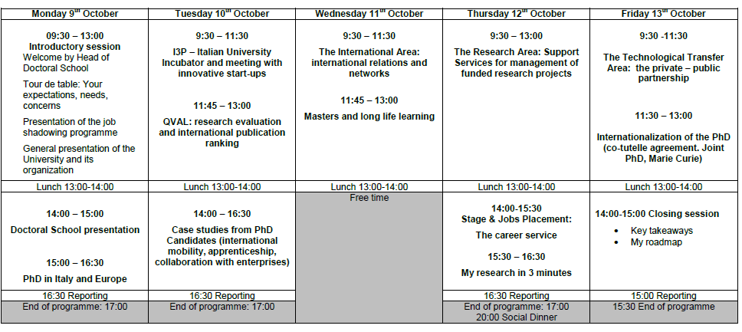

The purpose and method of the evaluation

According to the detailed project description to ensure the appropriate quality of the different actions a continued internal evaluation activity should be carried out.
Before the job shadowing event started ELTE contacted the Turin colleagues to become informed about the planned activities of the exercise in order to be able to develop a questionnaire which can reflect on the different elements of the activity.
The questionnaire was agreed by the Turing project team and it was distributed among the six Uzbek participants of the activity. Each items had to be evaluated on a four grade scale. All the participants filled in the questionnaire and after the job shadowing event was over all the questionnaires were sent to the ELTE project team. The evaluation results were calculated based on the average of each scale related to the content items. The maximum values could range between 4 and 1.
The data can be seen in the appendix in a summarised format.

Results

The participants found programme in general satisfactory (mean 3,1) and thought that it would be useful (mean 3,5) in their everyday activities in their home country.
They also considered that the individual thematic lectures and/or interactive sessions were either very useful or useful. The highest average evaluation (mean 3,6) was given to The Research Area: Support Services for management of funded research projects and Internationalization of the PhD (co-tutelle agreement. Joint PhD, Marie Curie). The lowest evaluation (mean 2,8) was given to The Technological Transfer Area: the private – public partnership.
The participants were fully satisfied or satisfied with the organisation of both the professional and the non-professional (leisure time) activities. The same impression articulated from the open ended questions: the participants enjoyed the job shadowing exercise and highly evaluated the professionalism of the Turin colleagues. The only criticism expressed was in relation to the too short periods of time spent on sight-seeing and other cultural events.

Conclusions
The programme was well organised and it was found useful by the participants.

Internal evaluation will show achieved project’s results, measure the achievements of every partner, the effectiveness of knowledge transfer within the consortium and the efficiency of the project management. It will evaluate main activities carried out by each partner during the monitored period, indicating the status of accomplishment of the tasks and the resources allocated to those activities. An internal evaluation tool - form containing self-evaluation and self-assessment questions - will be provided by WP leader for this task, facilitating controlling and monitoring of each partner’s activities in each step of the project using indicators of progress and measures. (Project description, p. 37)

